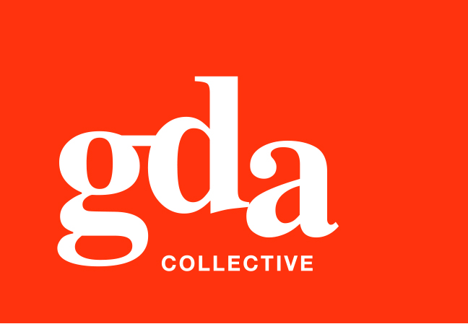
GDA Collective LLP
UEN: T20LL0431K
Ubi Ave 1 #06-09
Bizlink Centre
Singapore 408938

www.gda.sg

Quotation

To: Shannon Roche From: Gordon Choo
Assistant Director Marketing, Australia, Sales & Marketing GDA Collective LLP
Ascott International Management, Australia DID: +65 9818 8713
Email: gordon.choo@gda.sg

Date: 16 April 2020 Page(s): 1 (including this page)

Dear Shannon
Herewith we are pleased to submit the quote for lyf Digital Imaging Edit production for your perusal.

1. ‘lyf’ signage imposed on the building
2. Façade Edits: a. remove car plate and brand
b. Cafe edit
c. remove parking sign
d. remove tree on building top
e. remove light distraction on brick wall
f. remove all shadows on brick wall
g. remove all reflections and light spots on glass panels (x4)
h. remove standing lamp in room
i. remove shadow on top level
j. to proprose beacon signage placement on facade

Production: To provide the above services as indicated SGD 4,500
To provide final FA in PDF, Jpeg formats

Should you have further queries, please feel free to contact me at 9818 8713. We look forward to your early confirmation. Thank you and have a pleasant day.

Regards Agreed and Confirmed

__________________________________ __________________________________
Gordon Choo Gordon Choo Signature / Date / Company Stamp



