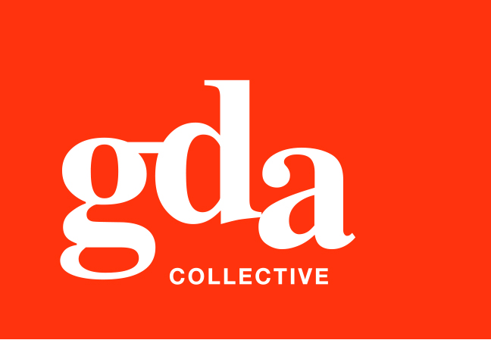
GDA Collective LLP
UEN: T20LL0431K
Ubi Ave 1 #06-09
Bizlink Centre
Singapore 408938

www.gda.sg

Invoice
Tatsuya Japanese Restaurant
Goodwood Park Hotel date May 04, 2020
22 Scotts Road Singapore 228221 delivery order no. -
payment terms 30 days
our ref no. -
Attn: Ms Noriko job no. J/F 3198

invoice no. INV-100001-20
description & value

Being cost for design production of Good Chance Restaurant
Parents Day 2020 Promotional Material
Brief descriptions: 01. Parents Day Promotion Flyer
02. Parents Day Mini Buffet Catering Flyer

Works: Design directions for initial composite SGD 150.00
Graphic design layout, SGD 150.00
Typography: typeset SGD 150.00
Project management, co-ordinations, press check SGD 150.00
Finish artworks and print specs visuals SGD 150.00

Grand Total SGD 150.00

We thank you for your business!

Please note:
Cheque/s should be crossed and made payable to GDA Collective LLP
If there should be any queries, please inform the person-in-charge and
return this bill to us within 3 days, otherwise this bill is deemed to be accepted.
Please send cheque to : 59 Ubi Avenue 1, #06-09, Bizlink Centre, Singapore 408938

––––––––––––––––––––––––––––––––––
Authorized Signatory / GDA Collective LLP



